-Remove the 4 screws of the locking mechanism. Once the locking mechanism and the rubber retainer are removed, you should see the following:
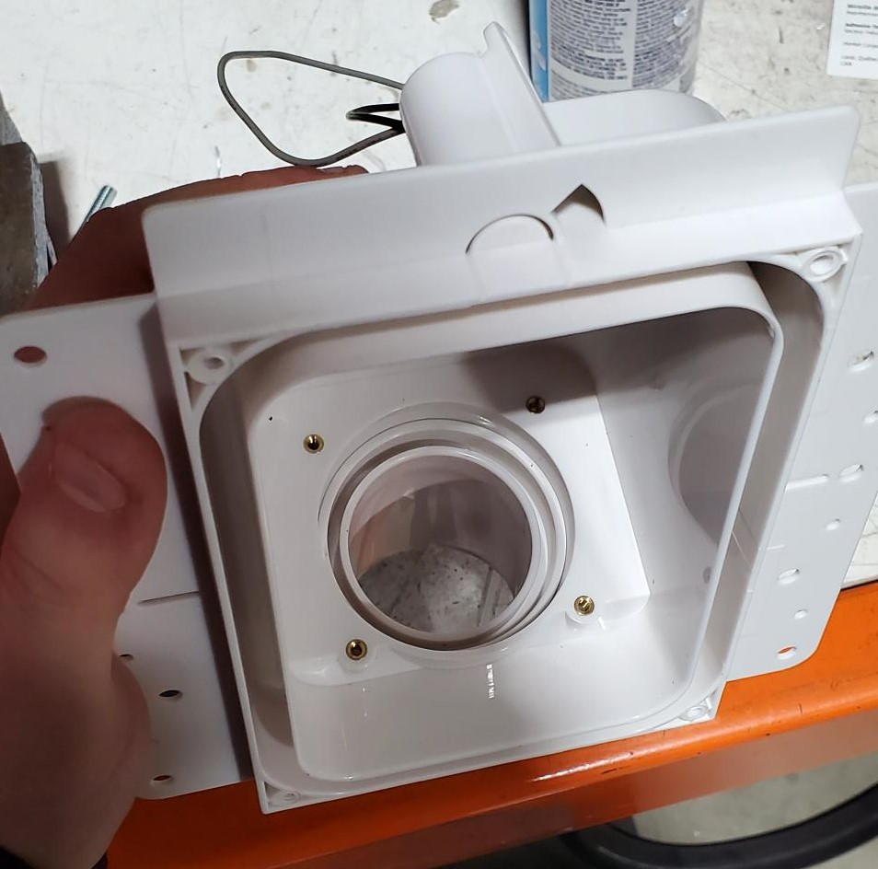

-Separate the old rubber retainer from the locking mechanism and discard.

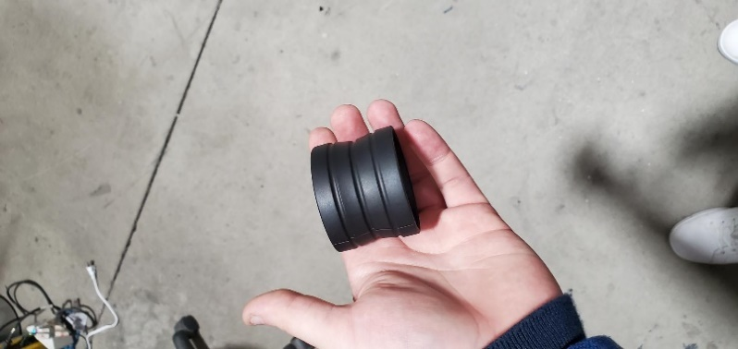
-Insert the new rubber retainer into the valve making sure that it is well seated in the channel found in the valve
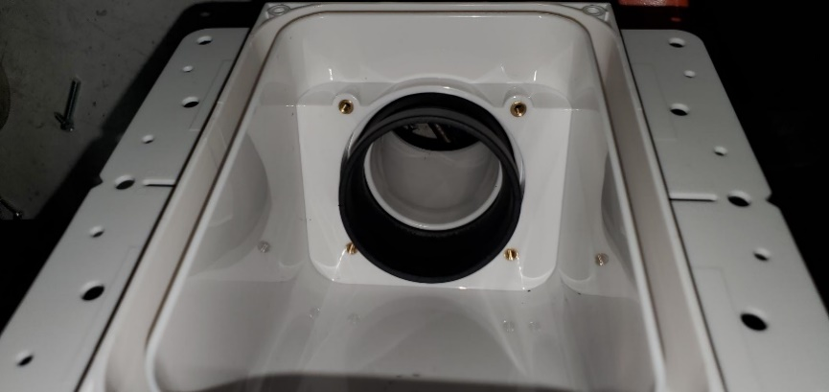

-Take the locking mechanism and find the channel where the rubber seal should be seated
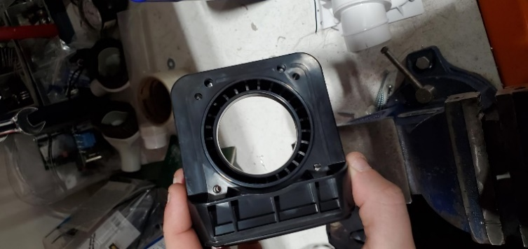

-Gently align the locking mechanism with the rubber seal which is already seated in the valve

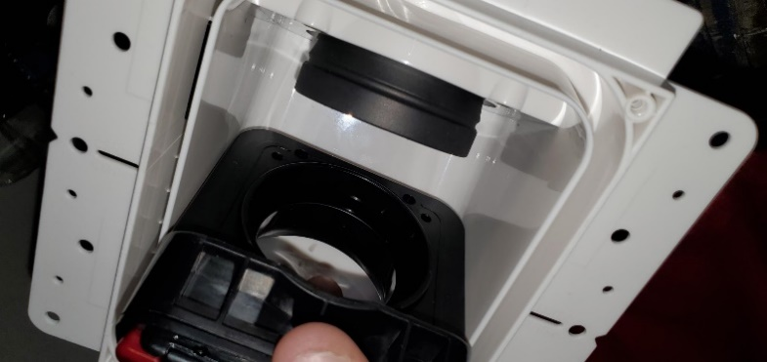
-When the locking mechanism is well placed, the rubber retainer should be situated between the white flange in the box the black flange in the locking mechanism. Touch inside of the rubber retainer to be sure. Last step is to screw down the locking mechanism.
